CPE301 – SPRING 2019

Design Assignment 4B

Student Name: John Duriman

Student #: 5002373995

Student Email: duriman@unlv.nevada.edu

Primary Github address: https://github.com/johnduriman/pirahnaplant.git

Directory: pirahnaplant/Design Assignments/DA4B/

1. **COMPONENTS LIST AND CONNECTION BLOCK DIAGRAM w/ PINS**

List of Components used:

Atmega328P

Jumper Wires

Bread board

Stepper motor

Servo motor

ULN2003

1. **INITIAL/MODIFIED/DEVELOPED CODE OF TASK 1/A**

1. **DEVELOPED MODIFIED CODE OF TASK 2/A from TASK 1/A**

1. **SCREENSHOTS OF EACH TASK OUTPUT (ATMEL STUDIO OUTPUT)**

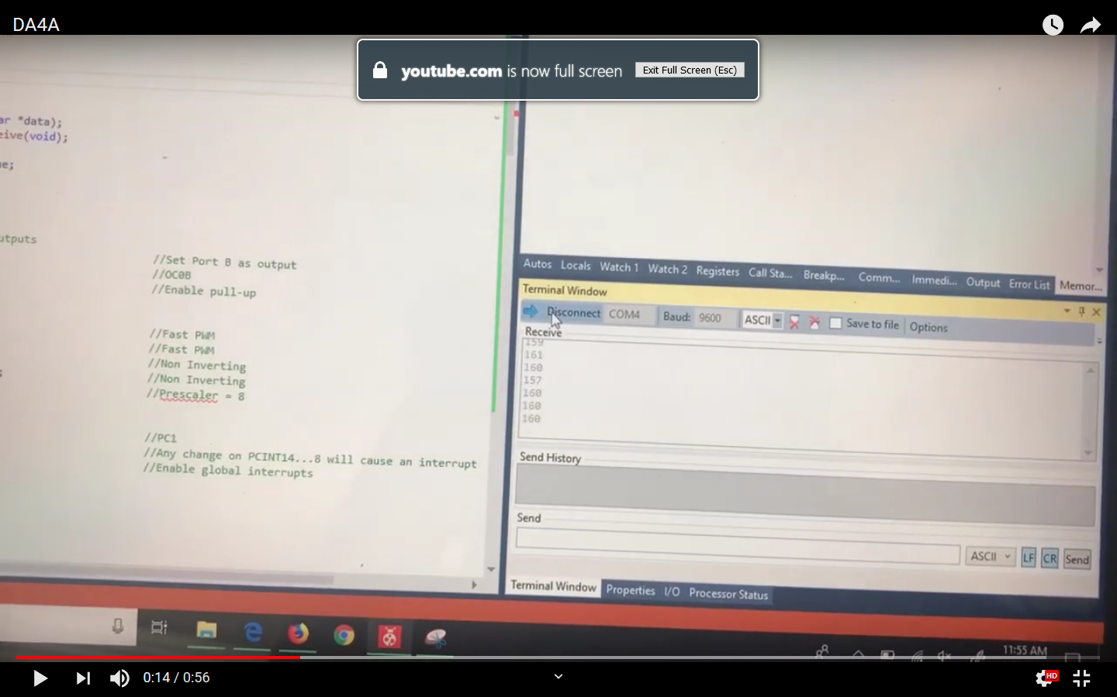

1. **SCREENSHOT OF EACH DEMO (BOARD SETUP)**
2. **VIDEO LINKS OF EACH DEMO**

N/A

1. **GITHUB LINK OF THIS DA**

https://github.com/johnduriman/pirahnaplant.git

**Student Academic Misconduct Policy**

<http://studentconduct.unlv.edu/misconduct/policy.html>

“This assignment submission is my own, original work”.

John Duriman